Grammar of Graphics to understand the dimensions of visuals.
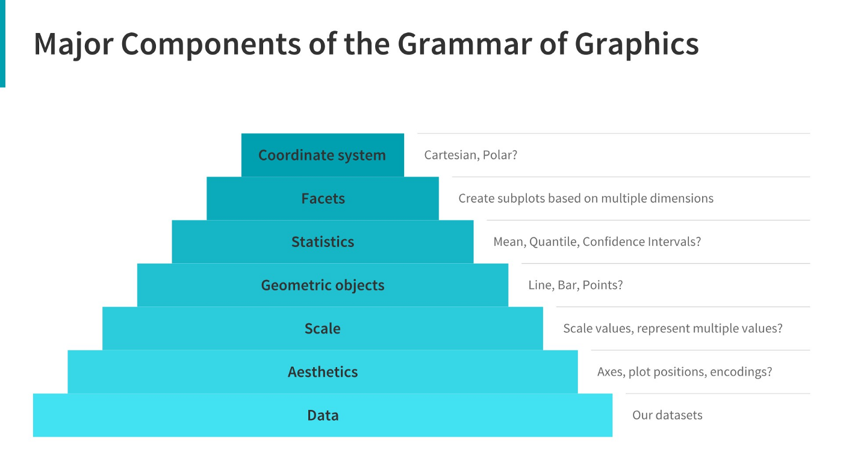
• A Comprehensive Guide to the Grammar of Graphics
Click to view website →
https://towardsdatascience.com/a-comprehensive-guide-to-the-grammar-of-graphics-for-effective-visualization-of-multi-dimensional-1f92b4ed4149

• How to Choose the Right Chart for Data Visualisation
Click to view website →
https://www.analyticsvidhya.com/blog/2021/09/how-to-choose-the-right-chart-for-data-visualization/
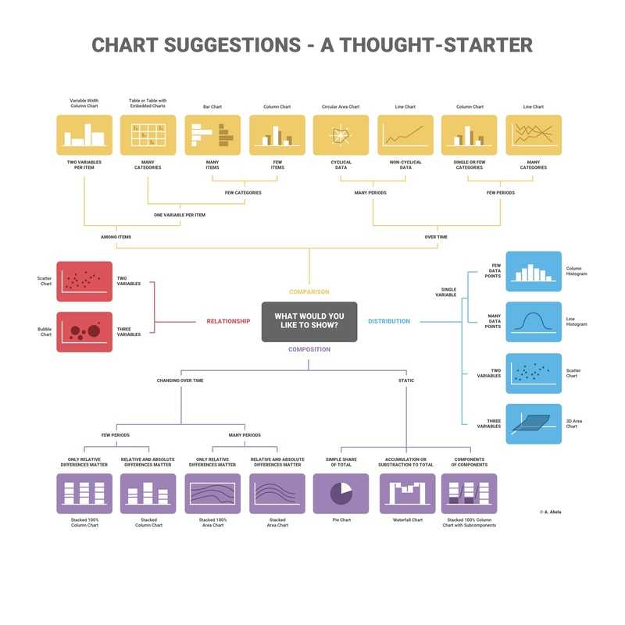
• How to Choose the Right Chart for Your Data
Click to view website →
https://infogram.com/page/choose-the-right-chart-data-visualization

• Additional Resources:
• Ultimate Guide to Choosing the Right Visual
Click to view website →
https://towardsdatascience.com/ultimate-guide-to-choosing-the-right-visual-2a77aa8eec08

• How to Choose the Right Data Visualisation
Click to view website →
https://chartio.com/learn/charts/how-to-choose-data-visualization/

• Which Type of Chart or Graph is Right for You?
Click to view website →
https://www.tableau.com/learn/whitepapers/which-chart-or-graph-is-right-for-you

